Process of Business site optimization

Product: Hoodie

# Keyword Research

In this part, I searched about our product trend key words. I will help to understand market trend.

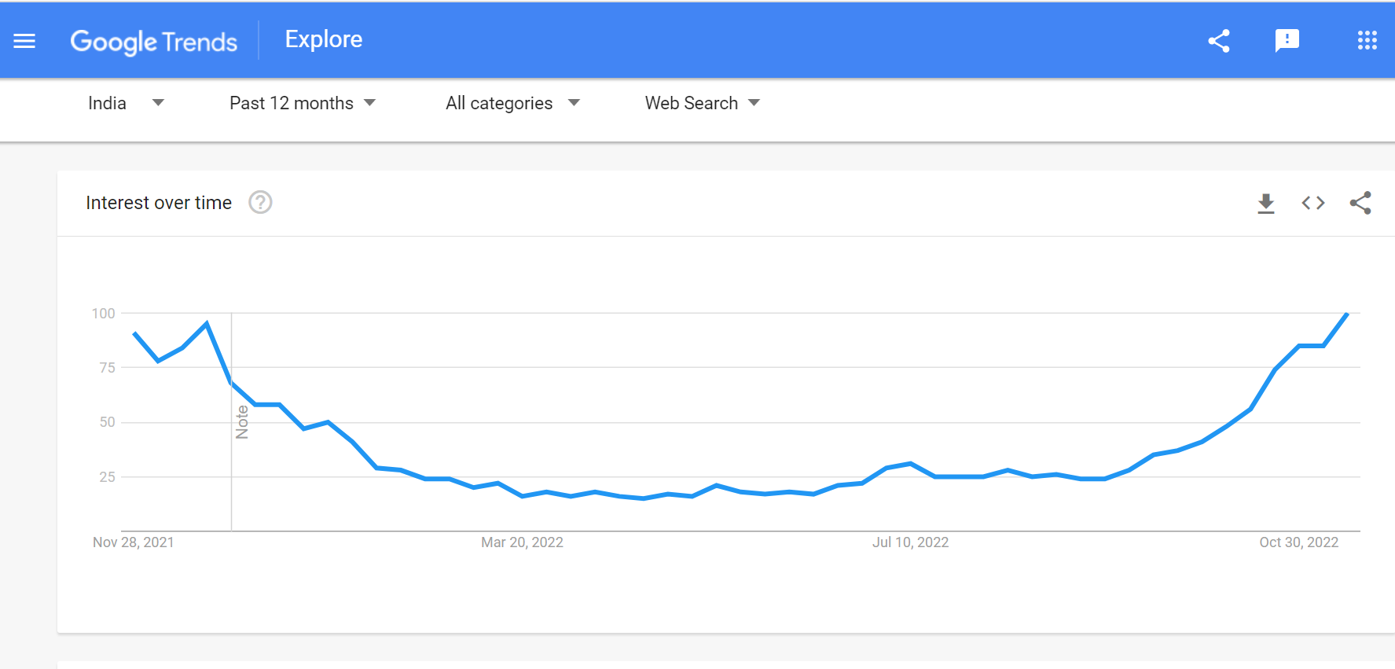

# Create Simple Site Navigation

It is used to provide good experience for the customer. Then customers will approach our site for their next purchase.



# Create Landing Pages

It is the main part for site optimization.

# Optimize Your Website for Mobile



Mobile optimization is must these days.

Most of the purchases are being done through mobile site.

# Check Site Speed

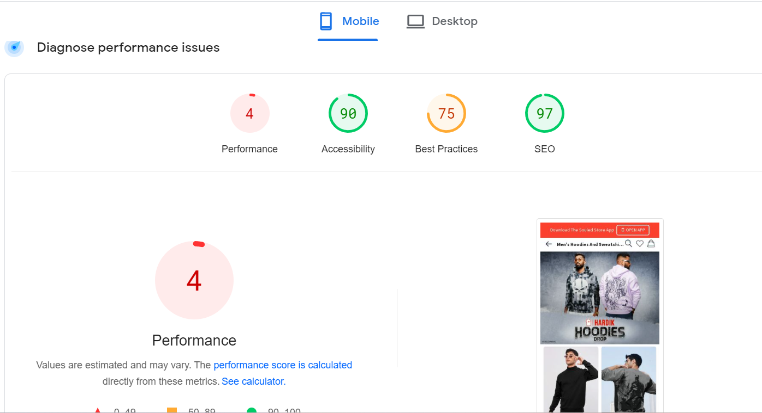

Conclusion:

* There are more tools available on internet.
* We can make or create new strategy with UX and UI to attract more customers.
* Search of the website also depends on the page loading speed.